**ECEN 248 - Lab Report**

**Lab Number: 3**

**Lab Title: Rudimentary Adder Circuits**

**Section Number: 519**

**Student’s Name:** [Alex Allahar](mailto:alex.allahar@tamu.edu)

**Student’s UIN: 928009686**

**Date: 09/27/23**

**TA: Yi Deng**

**Objectives:**

The purpose of this lab is to design various adders with digital logic gates. Starting with a half-adder, and working towards a 2-bit ripple carry adder.

**Design:**

Using the schematic from the prelab design a half-adder. Checking the design and logic with the Lab 3 Slide, verify the half adder by outputting the Sum and Carry out to two LEDs. Create a full-adder, using the full-adder design from the prelab. Using two LEDs, to verify the logic. Create the 2-bit ripple carry adder, using the design from the prelab. Use three LEDs to check the Sum 1, Sum 2, and the Carry out.

**Conclusion:**

In this lab, I built different adders. From a half-adder to a 2-bit ripple carry adder. Using LEDs to test the logic of the adder designs found in the prelab. The designs worked; however, one source of error was certain logic gates pins were not working properly.

**Post-lab Deliverables:**

1. The Full-Adder used in the prelab did not function during the lab. A new design was used, this new design’s schematic is shown below.

Half-Adder Design:

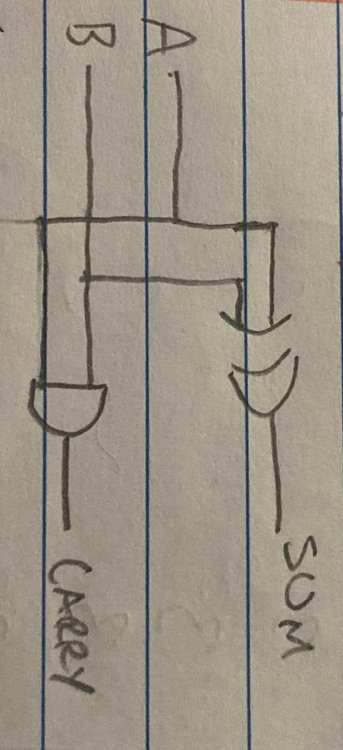

Full-Adder Design:

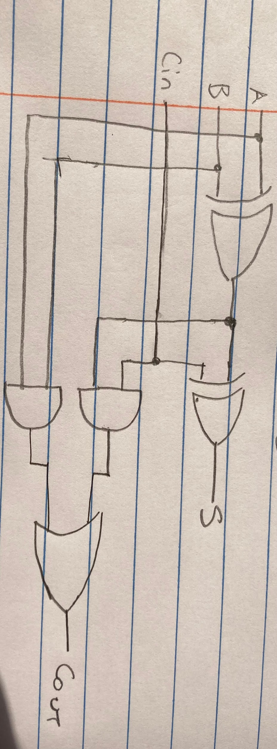

2-bit Ripple Carry Adder

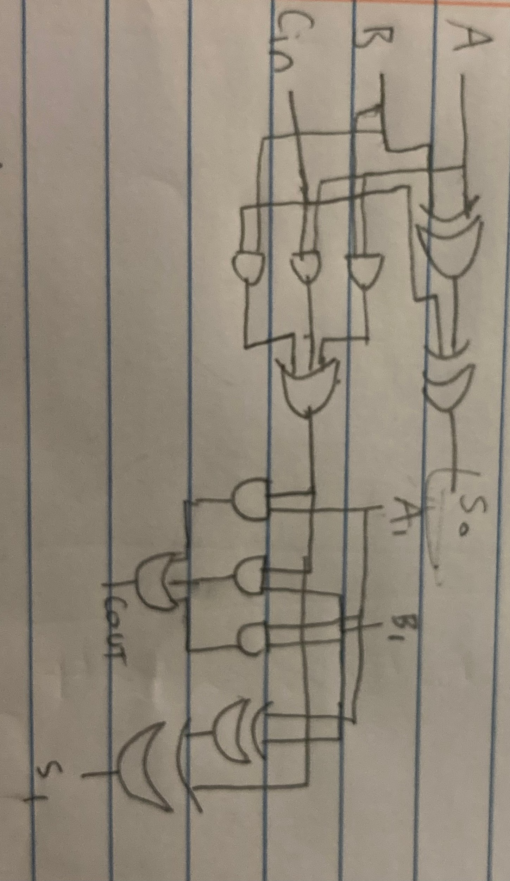

1. The worst propagation delay for the full adder design assuming each gate has the same delay of 1 unit, is 3. This path is from the A XOR B output to the AND gate with Cin, to the OR gate resulting in the Cout value.
2. A 2-bit Ripple Carry Adder design with half-adder circuits and OR gates:

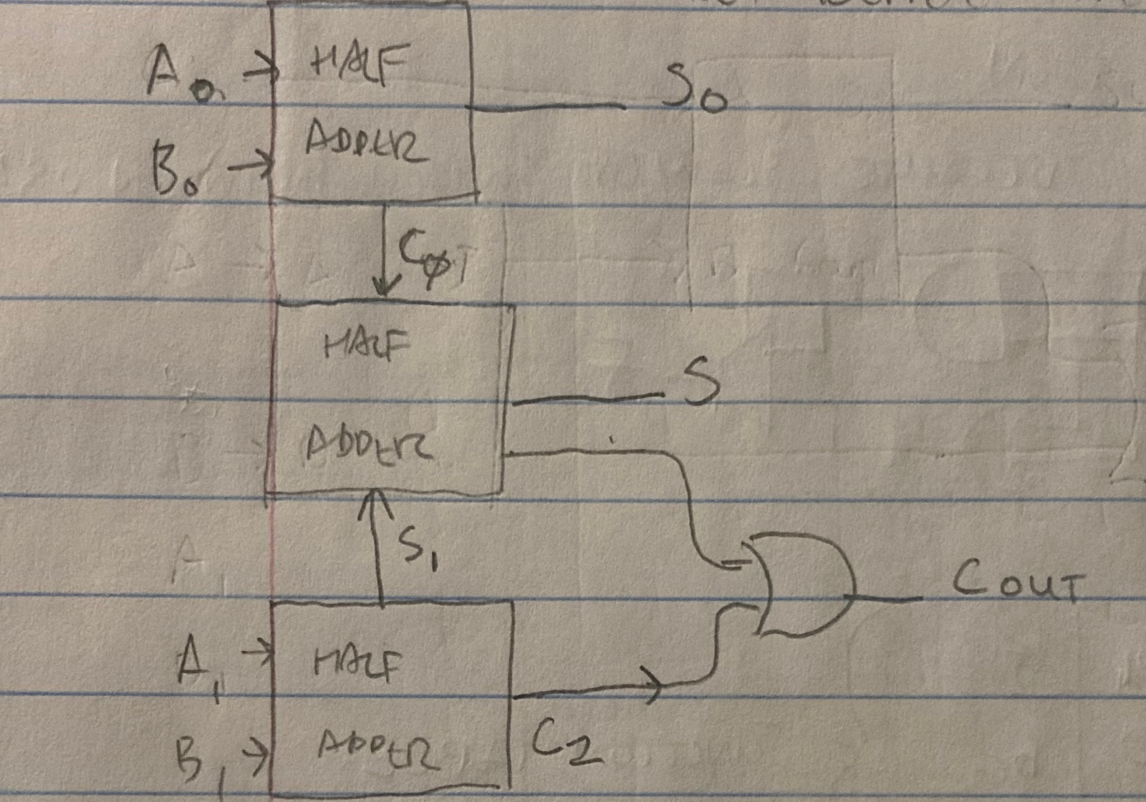

Feedback:

* Some of the ICs have only a few functional pins, which results in testing all pins of a logic gate before using or having to use more than the required amount of IC to design the circuit.